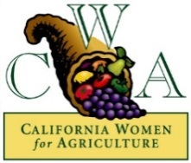

CENTRAL VALLEY CWA MEETING
Monday, October 26, 2015
Center for Irrigation Technology (CIT) Conference Room
5370 N. Chestnut Ave M/S OF 18
Fresno, CA 93740
5:30 pm

- Welcome and introduction

- Approval of Agenda

- Approval of September 28, 2015 Minutes – Eva Orum, Interim Secretary

- Approval of Treasurer's Report – Lauren Layne

- Old Business
- CVCWA Scholarships – Lily Reyes
- Membership/Donor Recruitment – Renewal and New – Stefani Dias
- November Statewide Meeting – Nov. 14-15, Murphys, CA
- Annual Convention Delegates – January 2016
- Community Service update – Monique Bienvenue

- Guest Speakers: Food Commons Fresno - Jan Minami,Trust Manager and Jenny Saklar, Operations Manager

- New Business:

- Slate of Officers for 2016 – President, Vice-President, Secretary, Treasurer. Accepting nominations from the floor
- Holiday Luncheon, December 11, 2015 – Kiah Tiftick
- Fundraisers for 2016
- Kathy Curtice – Ag crime update

- Items for future discussion

Future Meetings:
- November 30, 5:30, CIT Conference Room
- December 11, 11:30, Holiday Luncheon

